**Oakland Academy Hub**

**Authors**

Divya Davra

Ramya Kalyanapu

Soundarya Bachu

Swati Sonaji Kolpekwar

Contents

Task 1: System Vision Document 5

Introduction 5

Advantages 5

Growth 6

Drawbacks 6

Existing Competition 6

Problem Description 7

Limited Information Accessibility 7

Decision-Making Deficiency 7

Communication Gaps 7

Resource Scarcity 7

Insufficient Career Guidance 7

Digital Divide 7

Security Concerns 7

System Capabilities 9

Key Features 9

Expected Outcomes 9

Subsystems 9

Business Model 12

Oakland administration Fundraising 12

Sponsored Content 12

Subscription Model for Premium Features 12

Reference 12

Task 2: Stakeholder Register & System Requirements 13

Stakeholders 13

Functional Requirements 14

Non-Functional Requirements 18

Usability Requirements 18

Reliability Requirements 19

Performance Requirements 20

Security Requirements 21

Design Constraints 23

Implementation Requirements 23

Interface Requirements 24

Supportability Requirements 25

Task 3: Use Cases 27

Subsystem: Career Scope 27

Career Scope Use Case Diagram 28

Subsystem: Subject Library 29

Subject Library Use Case Diagram 30

Subsystem: Staff Review 31

Staff Review Use Case Diagram 32

Subsystem: Reports 33

Reports Use Case Diagram 34

Task 4: Entity Relationship Diagram (ERD) 35

draw.io file: 35

Task 5: Use Case Description and System Sequence Diagram (SSD) 36

View Scholarly Research Material use case description 36

View Scholarly Research Materials System Sequence Diagram 37

Generate Enrolment and Retention reports use case description 37

Generate Enrolment and Retention reports System Sequence Diagram 39

Access Alumni Success stories use case description 40

Access Alumni Success stories System Sequence Diagram 41

View Classroom environment use case description 42

draw.io file: 44

Task 6: User Interfaces 45

Login Interface 45

Subsystem: Career Scope 46

Job Roles and Titles User Interface 46

Alumni Success Story User Interface 46

Mentorship and Coaching Programs User Interface 47

Subsystem: Subject Library 47

Course Document User Interface 47

Feedback and Rating User Interface 48

Certification Information User Interface 49

Subsystem: Staff Review 50

Grading policy information User Interface 50

Information on research productivity and Impact User Interface 50

Information on classroom environment User Interface 52

Subsystem: Reports 53

Detailed course reports User Interface 53

Graduation and placement reports User Interface 54

Educational feedback user Interface 55

Link for Figma 55

Task 7: Design Class Diagram (DCD) 56

# Task 1: System Vision Document

## Introduction

The education Technology market, particularly in the context of reviews on professors, is witnessing a shift towards transparency and student empowerment. Students increasingly rely on peer reviews to make informed decisions about their courses and professors. This trend emphasizes the significance of platforms or apps facilitating honest and constructive feedback. According to a study, the U.S. education market size was worth around USD 1.41 trillion in 2021 and is predicted to grow to around USD 3.12 trillion by 2030 with a compound annual growth rate (CAGR) of roughly 4.21% between 2022 and 2030.

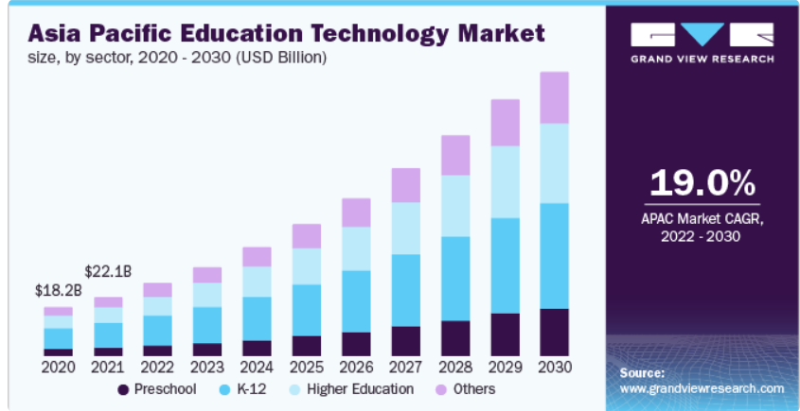

The sector is witnessing increased investment from various sources, including venture capitalists and major tech companies, fostering the growth of startups and the expansion of existing EdTech firms. The EdTech industry is at the forefront of this transformation; the industry is reshaping traditional classrooms and empowering educators and learners worldwide.

### Advantages

1. **Informed Decision-Making:** It helps make informed decisions when selecting courses or professors, potentially leading to a more satisfying academic experience. Benefits students by providing insights into teaching styles, grading criteria, and overall student experiences.
2. **Resource accessibility**: needful books, articles, and materials available.
3. **Diverse Learning Opportunities:** Access to a variety of courses, programs catering to different interests and career paths.
4. **Personalized preferences:** Adaptive learning technologies and personalized resources tailored to individual learning styles and preferences.
5. **Feedback** Accessing peer-generated feedback on professors.
6. **Skill Development:** Needful materials, lecture, and articles equips students with essential skills, both academic and practical, enhancing their employability and personal growth.
7. **Global Networking:** Opportunities to connect with students and employers from around the world, fostering a global perspective.
8. **Flexibility and Convenience:** EdTech offers flexibility in terms of when and where learning can take place. Students can access educational materials at their own pace, and working professionals can pursue further education without disrupting their careers.

### Growth

1. **Increasing Demand for Transparency:** Students seek transparency in their educational choices, and a platform offering professor comparisons fulfils this need by providing insights into teaching styles, workload, and overall experiences.

2. **Empowered Student Decision-Making:** As students take a more active role in shaping their education, platforms facilitating comparisons empower them to make informed decisions about their courses and professors.

3. **Focus on Quality of Education:** Institutions and students alike are placing a higher emphasis on the quality of education. Professor comparison platforms contribute to this focus by highlighting effective teaching methods and positive learning experiences.

4. **Tech Advancements:** Technological advancements, including user-friendly apps and data analytics, make it easier for students to access and contribute to professor comparisons.

### Drawbacks

**Lack of personal interaction:** Over Relianceon digital learning can reduce opportunities for face-to-face interaction and social development among students.

**Security concerns:** The digitization of academic processes raises concerns about data security and privacy.

**High Initial Costs:** Implementing and adopting EdTech solutions often involves significant upfront costs, including the purchase of hardware, software, and training for educators. This can be a barrier

**Technological Challenges:** Some learners may struggle with technological requirements, such as reliable internet connectivity and digital literacy, hindering their online learning experience.

### Existing Competition

Major players in the market include software providers offering comprehensive university management solutions. Competition is fierce, with companies continually innovating to provide more efficient and feature-rich applications, involving platforms offering features such as course management, event updates, and collaboration tools.

## Problem Description

In the contemporary educational landscape, students often face challenges in navigating their academic journeys due to the lack of a centralized platform that offers comprehensive information and insights. The "Oakland Academy Hub" project addresses several critical issues to enhance the overall academic experience.

### Limited Information Accessibility

Current academic systems often lack a unified platform where students can access detailed information about professors, courses, and career opportunities. Students may find it challenging to make informed decisions about their academic paths without a consolidated resource.

### Decision-Making Deficiency

A significant problem faced by students is the lack of insights into the teaching styles, grading criteria, and overall student experiences with professors. Making informed decisions about course selections or choosing the right professors can be a daunting task without peer-generated feedback and ratings.

### Communication Gaps

Communication between students and the academic community may suffer from inefficiencies. Traditional methods of communication may not provide students with timely updates on career fairs, job market demands, or mentorship opportunities, hindering their ability to stay connected with relevant information.

### Resource Scarcity

Students may struggle to find valuable resources for career development, such as articles, webinars, workshops and connecting to professors.

### Insufficient Career Guidance

The absence of a dedicated system for exploring career scope, compensation details, and alumni success stories leaves students without a comprehensive understanding of potential career paths. This deficiency can impact their ability to align their skills with emerging job demands.

### Digital Divide

An inherent drawback lies in the potential digital divide, where not all students may have equal access to every portal. This can create disparities in the utilization of applications like the Oakland Academy Hub, affecting the overall inclusivity and effectiveness of the system.

### Security Concerns

The digitization of academic processes raises legitimate concerns about data security and privacy. As academic information becomes increasingly digital, ensuring the confidentiality and integrity of student data becomes a critical aspect that needs to be addressed.

The problems we found make school a bit tough for students. The Oakland Academy Hub wants to make things better by creating a friendly place for students. It will help them pick the right classes and professors, get career advice, and connect with other students. The Hub plans to do this by adding cool features and making sure students have all the information they need to do well in school and later in their careers. The goal is to make school a better and easier experience for everyone in all perspectives.

## System Capabilities

The “**Oakland Academic Hub**” project aims to revolutionize the way individuals explore, plan, and excel in their professional lives where students can share reviews and access valuable information about faculty and courses to make informed decisions about their academic journeys.

Opportunities in this market include creating a comprehensive platform that not only allows students to review professors but also offers a holistic view of academic experiences. However, challenges may arise in maintaining the authenticity of reviews and addressing potential biases. In the era of dynamic professional landscapes, empowering individuals with the right tools and insights to navigate their journey is paramount.

To create a user-centric platform that provides comprehensive career scope information, facilitates meaningful connections within the professional community, and provides insights into potential career paths, job opportunities, and professional growth.

### Key Features

**1. Professor Ratings and Reviews:** A comprehensive database of ratings and reviews submitted by students, detailing their experiences with different professors.

**2. Criteria Comparison Tool:** Interactive features for users to compare professors based on specific criteria such as clarity, responsiveness, and grading methods.

**3. Anonymous Feedback System:** A secure platform for students to provide honest and constructive feedback while maintaining anonymity.

**4. Profiling System:** Individual profiles for each professor, displaying aggregated ratings, teaching history, and any additional relevant information.

### Expected Outcomes

The application serves as a comprehensive platform for students, offering valuable insights to select professors aligned with their learning preferences and facilitating continuous improvement through constructive feedback channels. With a resource hub providing career development resources like articles, webinars, and workshops, students make informed decisions by aligning their skills with industry trends. The platform also functions as a centralized job portal, connecting users with tailored job listings, internships, and employment opportunities. Beyond career support, it fosters community engagement, encouraging collaborative knowledge-sharing and networking with alumni and industry professionals. Additionally, real-life success stories inspire and guide users along their career paths, creating a holistic environment for academic and professional growth.

### Subsystems

#### Career Scope

1. **Compensation by career:** This includes the average salary ranges for different careers and helping students make informed decisions about their future employment.
2. **Positions:** In this, we can explore different types of job roles and job titles that individuals may hold within the system. These positions address explicit jobs that contribute to the unique career-related functionalities of the application providing students with guidance, resources, and support for their career development and success.
3. **Alumni Success Story:** This highlights the achievements and success stories of past students and the experiences that they have found success in their respective careers. This feature is designed to know the individual alumni profile, educational background, and career journey.
4. **Career fair:** Provides information about upcoming career fairs so that students can prepare for jobs and it is the direct interaction between students and employers.
5. **Booming skills:** This provides information about the emerging skill requirements for different careers for the students.
6. **Mentorship & Coaching programs:** It provides information about the mentors and coaching programs that students can participate in to get into various career paths in different professions.

#### Subject Library

1. **Course documents:** This provides information about the course syllabus, online textbooks and resources, lecture notes, and other essential course documents enhancing the learning experience.
2. **Course introductions:** It gives access to the introduction of all courses by Professors.
3. **Course ratings:** It enables the students to provide feedback and ratings for different courses and helps future students make informed decisions about their courses.
4. **Research documents:** It provides all scholarly research papers, articles, and publications for the students with valuable resources for in-depth exploration and academic study.
5. **Practice problems:** It consists of some practice exercises and allows students to apply theoretical knowledge, enhance problem-solving skills and gain practical experience through interactive learning.
6. **Certifications:** Provides information about the certifications for the students in different subject areas. They can access the certification programs, requirements, and preparation materials to enhance their skill set.

#### Staff Reviews

1. **Grading policy:** Students can access information about the grading criteria, exam formats, and overall assessment practices for particular courses of different faculty members. This includes reviews and feedback from the students about different faculty.
2. **Professor Feedback by Students:** The professor's background includes the professor's educational qualifications, research interests, and industry experience. This information aids students in gaining the qualifications of their professors and contributing to an enriched learning experience.
3. **Response Time:** It measures the time taken to respond to the faculty to student's emails and other inquiries.
4. **Research Productivity and Impact:** It provides insights into their research productivity, publications, records, and the impact of their work aiding students and researchers in identifying and engaging with faculty members who have made significant contributions to their respective fields.
5. **Contribution to the community and university:** This provides the information that faculty members made to the community and university like serving on committees, volunteering, or leading research projects that have a positive impact on the university.
6. **Classroom environment:** This section will have the feedback provided by students on professors' support in the learning.

#### Reports

1. **Student enrolment & retention rate:** This will provide information about the number of students enrolled in different courses and the programs and number of students who retain through semesters.
2. **Detailed course report:** This will provide information on professor details, schedule, location, pre-requisites.
3. **Course history:** This will provide a detailed report on each course, the number of students who completed the course, the average grade, pass rate, and attendance.
4. **Recommendations based on interests:** Suggest courses or study strategies based on the student's interest areas.
5. **Graduation rates & Placement data:** This will provide information on the graduation rates of students in different programs and the placement of graduates in jobs or further education
6. **Student satisfaction and feedback:** allows students to provide feedback on their educational experience and getting the best possible education. This feedback can be used to improve the quality of education and to identify areas where improvements can be made.

## Business Model

### Oakland administration Fundraising

* + **Description:** Reaching out to Oakland administration team for support in funding initial development for the application with proper demo and presentation of the application details.
  + **Processing:** providing detailed documentation and progress reports on a timely basis to the Oakland administration team.

### Sponsored Content

* + **Description:** Collaborate with relevant businesses, recruiters, or educational service providers to feature sponsored content, job postings, or targeted advertisements within the app/website.
  + **Revenue Collection:** Charge partner organizations for featuring their content or job listings on the platform. Establish clear terms and conditions for partnerships, including pricing models based on visibility and reach.
  + **Processing:** Develop a transparent and automated system for tracking sponsored content metrics and generating invoices. Use analytics to demonstrate the effectiveness of sponsored content to partners.

### Subscription Model for Premium Features

* + **Description:** Offer a subscription-based model for students who want access to premium features such as personalized career guidance, online textbooks, and exclusive content.
  + **Revenue Collection:** Implement a secure payment gateway within the app/website to collect subscription fees. Utilize widely accepted payment methods, including credit/debit cards or digital wallets.
  + **Processing:** Use a secure payment processing system to handle transactions. Ensure compliance with relevant financial regulations to safeguard student data and privacy.

## Reference

* <https://www.grandviewresearch.com/industry-analysis/education-technology-market>

# Task 2: Stakeholder Register & System Requirements

## Stakeholders

|  |  |  |  |
| --- | --- | --- | --- |
| Stakeholder Name | Position | Internal/External | Role |
| Yaman Roumani | Project Manager | Internal | Quality Assurance Manager |
| Divya Davra | Sr. System Analyst | Internal | System Analyst |
| Ramya Kalyanapu | Sr. System Analyst | Internal | System Analyst |
| Soundarya Bachu | Sr. System Analyst | Internal | System Analyst |
| Swati Sonaji Kolpekwar | Sr. System Analyst | Internal | System Analyst |

## Functional Requirements

|  |  |  |  |
| --- | --- | --- | --- |
| **Requirement ID** | **Requirement Statement** | **Must/Want** | **Comments** |
| FR001 | The system shall create accounts for new users. | Must | Account creation is the first feature we should have. |
| FR002 | The system shall process payments for subscription. | Want |  |
| FR003 | The system shall add the items to the cart. | Want | Cart functionality is essential for users to take further actions. |
| FR004 | The system shall provide average salary ranges for different careers. | Must | Offering salary insights helps students make informed decisions about career choices. |
| FR005 | The System Shall have different types of job roles and titles within the system. | Must | Job role visibility assists users in understanding the diverse career paths available. |
| FR006 | The System Shall provide Alumni Success Stories. | Must | Highlights achievements and success stories of past students, including individual alumni profiles, educational backgrounds, and career journeys. |
| FR007 | The System Shall provide information about upcoming career fairs. | Must | Enables students to prepare for job opportunities and facilitating direct interaction between students and employers. Access to career fair details enables students to prepare and participate in networking opportunities. |
| FR008 | The System Shall have information about emerging skill requirements for different careers. | Must | Identifying emerging skills help students align their education with current industry demands. |
| FR009 | The System Shall provide information about available mentorship and coaching programs. | Must | Allows students to participate in programs that guide them into various career paths. |
| FR010 | The System Shall provide information about course syllabus, e-books, lecture notes, and other essential course documents to enhance the learning experience. | Must | Access to course materials is crucial for effective learning and academic success. |
| FR011 | The System Shall provide access to introductions of all courses by Professors. | Must | Course introductions provide students with a clear understanding of course expectations. |
| FR012 | The System Shall provide feedback and ratings for different courses. | Must | Student feedback enhances transparency and aids students in course selection. |
| FR013 | The System shall provide access to scholarly research papers, articles, and publications. | Must | Offers valuable resources for in-depth exploration and academic study. |
| FR014 | The System Shall provide practice exercises. | Must | Allows students to apply theoretical knowledge, enhance problem-solving skills, and gain practical experience through interactive learning. |
| FR015 | The System Shall provide information about certifications in different subject areas. | Must | Includes access to certification programs, requirements, and preparation materials to enhance students' skill sets. |
| FR016 | The System Shall provide students with information about the grading criteria, exam formats, and overall assessment practices for particular courses taught by different faculty members. | Must | Grading information is crucial for students to understand course expectations and assessment methods. |
| FR017 | The System Shall provide feedback on professors, including details about their educational qualifications, research interests, and industry experience. | Must | Professor feedback aids students in choosing courses and professors aligned with their academic goals. |
| FR018 | The System Shall provide the time taken by faculty members to respond to students' emails and other inquiries. | Must | Response time metrics contribute to effective communication and student-faculty interaction. |
| FR019 | The System Shall provide insights into faculty members' research productivity, publications, records, and the impact of their work, aiding students and researchers in identifying and engaging with faculty members who have made significant contributions to their respective fields. | Must | Research insights help students identify faculty members with significant contributions in their fields. |
| FR020 | The System shall provide information about the contributions faculty members have made to the community and university, such as serving on committees, volunteering, or leading research projects that have a positive impact on the university. | Must | Faculty contributions showcase their involvement and impact within the academic community. |
| FR021 | The System Shall include feedback from students on the classroom environment, capturing their opinions on professors' support in the learning process. | Must | Classroom feedback helps students understand the learning environment and support provided by professors. |
| FR022 | The System Shall generate reports providing information about the number of students enrolled in different courses and programs, including the retention rate of students through semesters. | Must | Enrolment and retention reports provide insights into course popularity and student engagement. |
| FR023 | The System Shall generate detailed reports on each course, including professor details, schedule, location, pre-requisites, and other relevant information. | Must | Detailed course report assists students in making informed decisions about course selection. |
| FR024 | The System Shall generate reports on the history of each course, including the number of students who completed the course, average grades, pass rates, and attendance. | Must | Course history reports offer a comprehensive view of course outcomes and student performance. |
| FR025 | The System Shall generate reports suggesting courses or study strategies based on the student's interest areas. | Must | Personalized recommendations support students in aligning their academic path with their interests. |
| FR026 | The System Shall generate reports on the graduation rates of students in different programs and provide information on the placement of graduates in jobs or further education. | Must | Graduation and placement data offer insights into the success of students in various programs. |
| FR027 | The System Shall provide feedback on their educational experience, and the collected feedback shall be used to improve the quality of education and identify areas for improvement. | Must | Student feedback is valuable for continuous improvement and enhancing the overall educational experience. |

## Non-Functional Requirements

### Usability Requirements

|  |  |  |  |
| --- | --- | --- | --- |
| Requirement ID | Requirement Statement | Must/Want | Comments |
| UR001 | The system shall use the OU official colors (Black and #BC945b) | Must |  |
| UR002 | The system shall have documentations for users (Help/FAQ) | Must |  |
| UR003 | The system shall have a User Profile Tab | Must | Allows users to manage profile |
| UR004 | The system shall use swipe left/right/up/down gestures | Must |  |
| UR005 | The System shall have zoom in and zoom out with pinch in and expanding actions | Want | zoom in and zoom out will help in better readability. |
| UR006 | The System shall have facility for enabling notifications based on user preference. | Want | Notification will help users for better communication. |
| UR007 | The System shall have 2 finger slides features to move to and fro among the pages. | Want | 2 finger slides feature help for easy handling. |
| UR008 | The System shall have subject limit as 200 words and description limit as 1000 words in the discussion forum in Mentorship & Coaching programs section. | Must | For better database management. |
| UR009 | The System shall have document attachment feature for word and pdf formats not exceeding 200 MB and have maximum limit of 9 files in the discussion forum in Mentorship & Coaching programs section. | Must | Maximum file size: 200 MB, maximum number of files: 9 |
| UR010 | The system shall have permission to access latest initial recordings of every course accordingly and textbook pdfs which will be updated from time to time. | Must |  |

### Reliability Requirements

|  |  |  |  |  |  |  |  |  |
| --- | --- | --- | --- | --- | --- | --- | --- | --- |
|  | Requirement ID | | Requirement Statement | | Must/Want | | Comments | |
| RR001 | | The system shall be available 99.99%. | | Must | | Students will depend on this platform for important information if the platform is down, they will lose the trust in it.  [Link](https://www.coresite.com/blog/breaking-down-data-center-tiers-classifications) | |
| RR002 | | The system shall have recovery time 2 hours according to nature of our application. | | Want | | If there is any downtime it should recover in 2 hours. | |
| RR003 | | The system shall have high availability and disaster recovery with failover servers in place to act in case of server failure. | | Must | | It helps to maintain continuous service without disturbing the students. | |
| RR004 | | Need to maintain at least 99.99% data accuracy for the course information, reviews and career resources to reduce the inaccuracy. | | Must | | Data accuracy is important as wrong information may confuse users in selecting choices about their work and career decisions.  [Link](https://en.wikipedia.org/wiki/High_availability) | |
| RR005 | | The system shall have significant performance and scalability, capable of serving 5000+ users at a time. | | Want | | According to our calculation on Oakland University population, we came to 3000 users, 2000 as threshold. | |
| RR006 | | The system shall have technological advancements with the market changes and platform demand which will help response time between 0.1 to 1 seconds. | | Want | | It helps to keep the platform better to use and can stay long term.  [Link](https://testsigma.com/blog/response-time-testing/) | |

### Performance Requirements

|  |  |  |  |
| --- | --- | --- | --- |
| Requirement ID | Requirement Statement | Must/Want | Comments |
| PR001 | Response Time: The system shall respond to the user request within 0.5 seconds. | Must | [Link](https://www.nngroup.com/articles/response-times-3-important-limits/) |
| PR002 | Reliability: The reliable rate for system failures or errors must be 0.5%. | Must | [Link](https://www.mometrix.com/academy/precision-accuracy-and-error/) |
| PR003 | Load testing: Shall perform well under different load systems. | Must |  |
| PR004 | User experience: The page loading time, Image rendering, and interactive elements between 1-3 seconds. | Must | [Link](https://uxplanet.org/how-page-speed-affects-web-user-experience-83b6d6b1d7d7) |
| PR005 | Concurrency: Maximum 2 devices are allowed for the same account; it can be increased to 4 with subscription. | Want |  |
| PR006 | Upon submitting a request to create a new user profile, the profile should be created in 2.1 seconds. | Must |  |
| PR007 | Login must be completed in less than 3 seconds. | Must | [Link](https://askubuntu.com/questions/1479007/not-able-to-enter-password-for-few-seconds-at-login-screen-in-kubuntu-23-04) |
| PR008 | Available courses should be found in less than 2 seconds. | Must | [Link](https://www.nngroup.com/articles/response-times-3-important-limits/) |
| PR009 | Purchase of the textbook’s pdf should not take more than 10 seconds. | Must |  |
| PR010 | The download of the web page containing 512KB of text, the latency must not be greater than 0.9 seconds. | Must | [Link](https://www.greennet.org.uk/support/understanding-file-sizes) |
| PR011 | The system shall provide access to the pdf textbook bought by user within 10 seconds of buying. | Want |  |
| PR012 | A good download speed is considered to be 100 Mbps, whereas a good upload speed is at least 10 Mbps. | Must | [Link](https://www.techtarget.com/searchunifiedcommunications/definition/data-transfer-rate) |
| PR013 | The system shall be available for 24/7 for 363 days in any one-year calendar. | Must |  |
| PR014 | Data transfer rate: The user can send a file with a maximum file size of 5MB. | Must | [Link](https://www.cmd-ltd.com/advice-centre/usb-chargers-and-power-modules/usb-and-power-module-product-help/data-transfer-rate/) |

### Security Requirements

|  |  |  |  |
| --- | --- | --- | --- |
| Requirement ID | Requirement Statement | Must/Want | Comments |
| SR001 | The system shall use a complex password, password should be between 8-16 characters of length including at least one special character, capital letter, and number. | Must |  |
| SR002 | The system shall use 2FA (Two-Factor Authentication). | Want | Two-Factor Authentication is a desirable additional layer of security for user authentication. For example: Cisco. |
| SR003 | The system shall use the HTTPS protocol. | Must | Enforcing the use of HTTPS ensures secure communication between the user's browser and the system, protecting data during transit. |
| SR004 | The system shall implement account lockout after 3 failed login attempts. | Must | Account lockout enhances security by preventing unauthorized access. Link: |
| SR005 | The system shall encrypt sensitive user data stored in the database. | Must | Encryption safeguards sensitive information stored in the system, adding an extra layer of protection. |
| SR006 | The system shall regularly update and patch software and libraries. | Must | Regular updates and patches address vulnerabilities and improve the overall security posture of the system. |
| SR007 | The system shall log and monitor user activities. | Must | Logging and monitoring user activities help detect and respond to suspicious or unauthorized actions. |
| SR008 | The system shall have role-based access control (RBAC). | Must | Role-based access control ensures that users have access only to the functionalities and data relevant to their roles. |
| SR009 | The system shall conduct periodic security audits and assessments. | Must | Security audits identify and address potential vulnerabilities, ensuring ongoing system security. |
| SR010 | The system shall implement session timeouts for user inactivity for more than 10min. | Must | Session timeouts reduce the risk of unauthorized access by terminating inactive sessions. |
| SR011 | The system shall have asymmetric encryption communication between system components. | Must | Encrypting communication between system components protects data in transit and prevents unauthorized access. |
| SR012 | The system shall have a secure mechanism for password recovery/reset. | Must | A secure password recovery/reset mechanism provides a balance between security and user convenience. |
| SR013 | The system shall have intrusion detection and prevention mechanisms based on previous location. | Must | Intrusion detection and prevention help identify and mitigate security threats in real-time. |
| SR014 | The system shall restrict access to sensitive configuration files. | Must | Restricting access to configuration files prevents unauthorized modification that could compromise system security. |
| SR015 | The system shall have a mechanism to notify users of suspicious account activities through email. | Want | Notification of suspicious activities enhances user awareness and allows them to take corrective actions. |
| SR016 | The system shall have a secure mechanism for handling and storing user payment information. | Must |  |
| SR017 | The system shall conduct regular security training for system administrators. | Must | Security training for administrators ensures awareness and adherence to best practices in maintaining system security. |

### Design Constraints

|  |  |  |  |
| --- | --- | --- | --- |
| Requirement ID | Requirement Statement | Must/Want | Comments |
| DR001 | The system shall be compatible with both Android and iOS operating systems to ensure accessibility for a wide range of users. | Must |  |
| DR002 | The system shall be no more than 100 MB in size in both Android and iOS | Must | As per our analysis, Moodle application is 74 MB in size and based on this we are estimating 100 MB for Oakland Academy Hub. |
| DR003 | The system shall run on a smart phone with a minimum of 1.8 GHz (Android/iOS). | Must |  |
| DR004 | The system shall have resource utilization support CPU, memory, and storage for utilization of resources and can handle up to 64GB of RAM. | Must | [Link](https://docs.ceph.com/en/quincy/start/hardware-recommendations/) |

### Implementation Requirements

|  |  |  |  |
| --- | --- | --- | --- |
| Requirement ID | Requirement Statement | Must/Want | Comments |
| IMR001 | The system shall use Swift programming language (iOS). | Must | The swift programming language delivers a smooth experience for resource downloads in IOS. |
| IMR002 | The system shall use Java programming language (Android). | Must | By using Java programming in Android users may access various features in their android devices. |
| IMR003 | The system shall use JavaScript frameworks like React JS for the UI development. | Must | It helps to run the website better and make the buttons and pages work smoothly. |
| IMR004 | The application can use RDBMS like My SQL for Data Integrity. | Must | RDMS is critical for data management including user profiles, reviews, and ratings. |
| IMR005 | The system should maintain combined documentation API tools like swagger to generate interactive APIs automatically from code. | Must | Documentation makes it easier for developers to understand the process and it will help in similar developments. |
| IMR006 | Need to implement standard protocol communication like restful API for productive data exchange. | Must | It interacts with the frontend and backend of Oakland academy hub to make the system productive and exchange data.  [Link](https://www.astera.com/type/blog/rest-api-definition/) |

### Interface Requirements

|  |  |  |  |
| --- | --- | --- | --- |
| Requirement ID | Requirement Statement | Must/Want | Comments |
| INR001 | Hardware interface:  The system shall provide easy connection with the external audio devices. Eg. Earphones (wired or Bluetooth), Speaker | Must |  |
| INR002 | Interoperability: The system shall provide smooth interoperability with other systems with minimized latency. | Must | The system shall use popular third-party applications like image viewer, YouTube for links, PayPal for payments. |
| INR003 | Security Interface: The system shall secure authentication and authorization mechanisms. | Must |  |
| INR004 | Data interface: The system shall support exporting data in common formats. | Must |  |
| INR005 | Error handling: The system shall easily address error issues.  Effectively handling operational errors. | Must |  |
| INR006 | Synchronization mechanism:  Can save a few files from the application to Google Drive. | Want |  |

### Supportability Requirements

|  |  |  |  |
| --- | --- | --- | --- |
| Requirement ID | Requirement Statement | Must/Want | Comments |
| SUPR001 | The system shall be compatible with major web browsers such as Mozilla Firefox, Google Chrome, Microsoft Edge, Safari, and others. | Must | Ensuring compatibility with popular ones enhances accessibility. |
| SUPR002 | The system shall design the application with a modular architecture, allowing for independent development and updates of different components. | Must | Adaptation should change as updates can be made to specific features without affecting the entire system. |
| SUPR003 | The system shall provide administrators with a user-friendly interface to configure system settings, preferences, and policies. | Must | Configuration changing requirements without extensive development efforts. |
| SUPR004 | The system should be designed to handle an increasing number of users, reviews, and data over time. | Want | As the user increases and data grows, the application should scale seamlessly to maintain performance and responsiveness. |
| SUPR006 | The system shall adhere to robust security practices, including encryption, secure data storage, user authentication, and compliance with privacy regulations. | Must | Configurability:  Security is paramount, especially when handling sensitive information about students, professors, and academic data. |
| SUPR007 | The system shall have automated testing processes, including unit tests, integration tests, and regression tests. | Must | Automated testing improves efficiency, repeatability, and the overall reliability of the testing process. |
| SUPR008 | The application code should be modular, with well-defined structures for different components. | Want |  |
| SUPR009 | The installation or upgradation process should contain a workable uninstall, downgrade, or backoff process in case a specific installation does not proceed as expected. The installation or upgradation process should correctly work from all of the various delivery media, | Want | [Link](https://www.softwaretestinggenius.com/checklist-for-system-installability-and-upgradability-acceptance-criteria/#:~:text=Installability%20and%20Upgradability%20The%20purpose%20of%20system%20installability,software%2C%20it%20is%20required%20to%20be%20done%20smoothly.) |

# Task 3: Use Cases

## Career Scope Subsystem

|  |  |  |  |
| --- | --- | --- | --- |
| ID | Use Case | Actor | Description |
| 1 | Show Average Salary Ranges | Student | Students can access the system to obtain average salary ranges for different careers. |
| 2 | Show Job Roles and Titles | Student | Students can access and explore information on various job roles and titles within the system. |
| 3 | Show Alumni Success Stories | Student | Students can access alumni success stories within the system. |
| 4 | Show Career Fair Information | Student | Students can stay informed about upcoming career fairs through the system, ensuring they can connect with employers. |
| 5 | Show Emerging Skill requirement information | Student | Students can access information about the emerging skill requirements for different careers. |
| 6 | Show Mentorship and coaching Programs | Student | Students can utilize the system to find information about available mentorship and coaching programs. |

## Career Scope Use Case Diagram

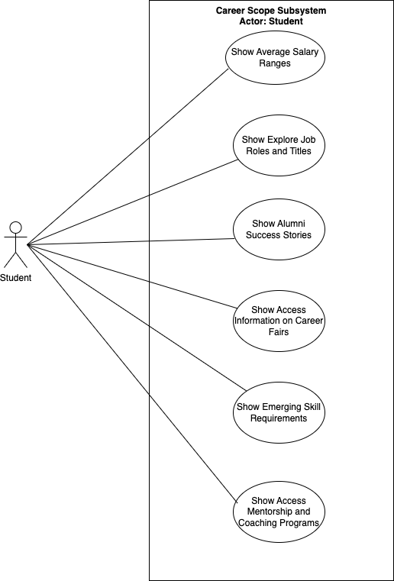

## Subject Library Subsystem

|  |  |  |  |
| --- | --- | --- | --- |
| ID | Use Case | Actor | Description |
| 1 | Show Course Documents | Student | The student initiates a request to access various course-related documents for effective learning and academic success. |
| 2 | Show Course Introductions | Student | Students can access course introductions with a clear understanding of course expectations. |
| 3 | Show Feedback and Ratings | Student | Students can access feedback and ratings for specific course selection aiding in the continuous evaluation and enhancement of the educational experience within the system. |
| 4 | Show Scholarly Research Materials | Student | Users initiate a request to access scholarly research papers, articles, and publications, facilitating academic exploration and in-depth study. |
| 5 | Show Practice Exercises | Student | Students can access practice exercises, enabling interactive learning and skill development. |
| 6 | Show Certification Information | Student | Students can access certification programs, requirements, and preparation materials to enhance skill sets. |

## Subject Library Use Case Diagram

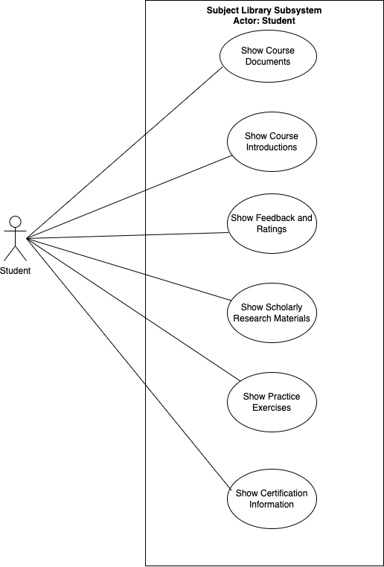

## Staff Review Subsystem

|  |  |  |  |
| --- | --- | --- | --- |
| ID | Use Case | Actor | Description |
| 1 | Show grading policy information | Student | On user request System Shall provide students with information about the grading criteria, exam formats, and overall assessment. |
| 2 | Show feedback on professors | Student | On user request System Shall provide feedback on professors |
| 3 | Show information on response time | Student | On user request System Shall provide Faculty members response Time |
| 4 | Show information on research productivity and Impact | Student | On user request System Shall provide Research Productivity and Impact |
| 5 | Show information on contribution to the community and university | Student | On user request System Shall provide information on Contribution to the community and university |
| 6 | Show info on classroom environment | Student | On user request System Shall Provide information on Classroom environment |

## Staff Review Use Case Diagram

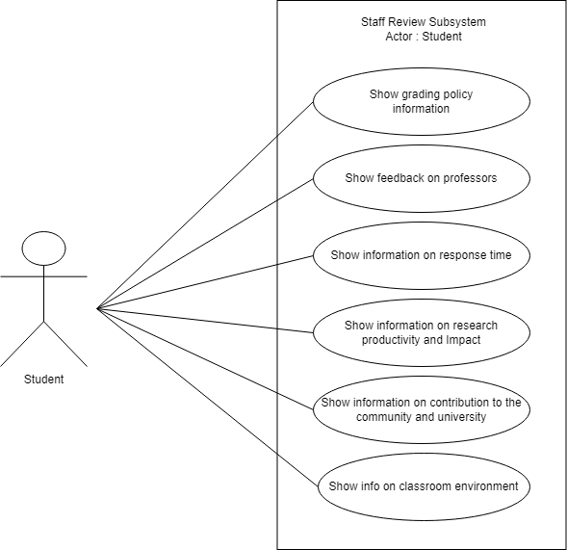

## Reports Subsystem

|  |  |  |  |
| --- | --- | --- | --- |
| ID | Use Case | Actor | Description |
| 1 | Show enrolment and retention reports | Student | The student receives detailed reports containing enrolment information for selected courses and programs. |
| 2 | Show detailed course reports | Student | On students request system shall provide detailed reports containing comprehensive information about the selected course. The reports include schedule, location, pre-requisites, and other details for better academic planning. |
| 3 | Show course history report | Student | The student receives the historical data for the selected course. The reports include completion statistics, average grades, pass rates, attendance records, aiding in course evaluation and improvement. |
| 4 | Show personalized study recommendation | Student | The student receives personalized study recommendations based on interest areas and academic goals. |
| 5 | Show graduation and placement reports | Student | The student receives the detailed reports containing graduation rates and placement information for the selected program. |
| 6 | Show educational feedback | Student | The students receive the collected feedback to improve the quality of education and identify areas for improvement. |

## Reports Use Case Diagram

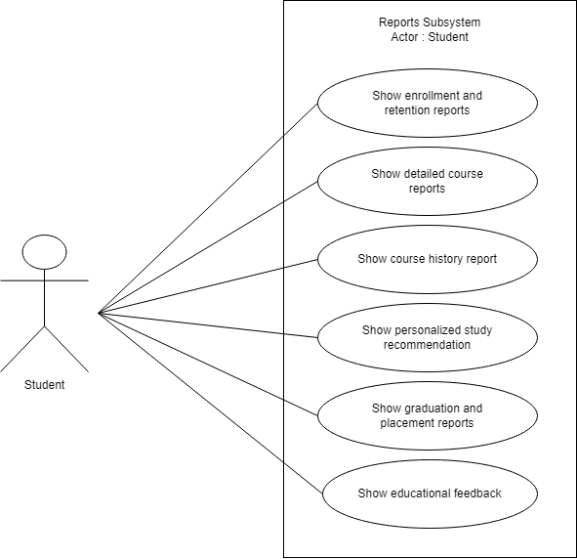

# Task 4: Entity Relationship Diagram (ERD)

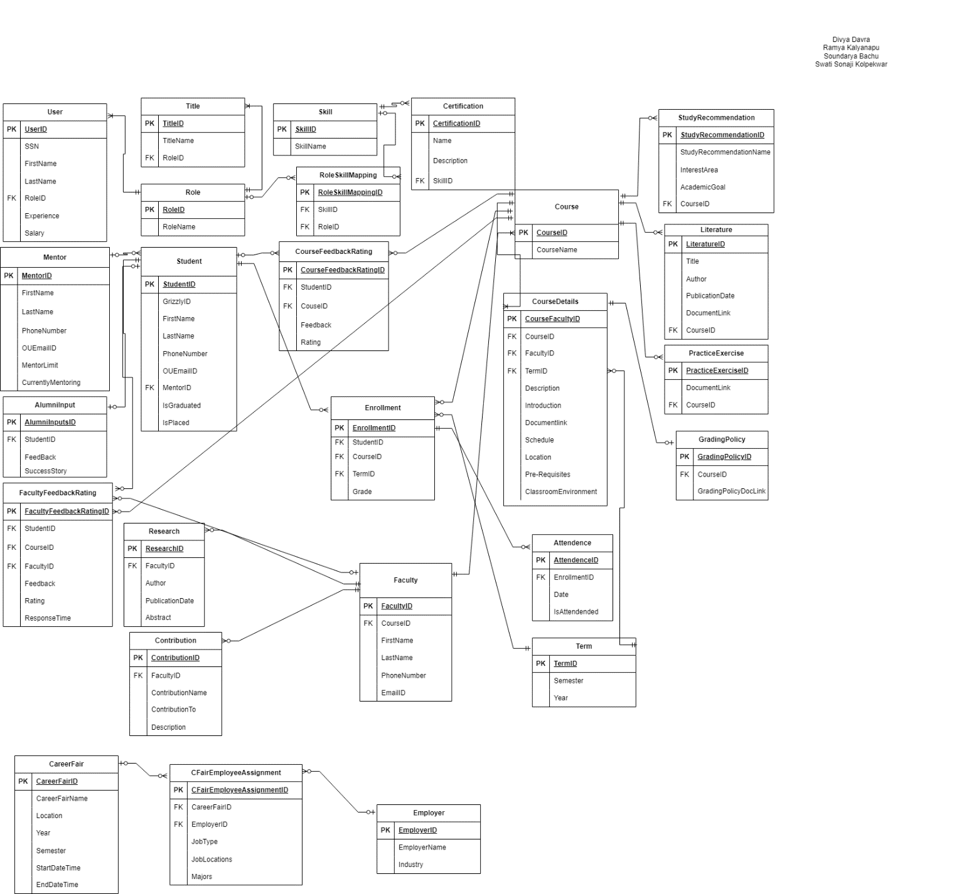

### draw.io file



# Task 5: Use Case Description and System Sequence Diagram (SSD)

## View Scholarly Research Material use case description

|  |  |  |
| --- | --- | --- |
| **Use case name:** | View Scholarly Research Material | |
| **Scenario:** | Seeks to access scholarly research material | |
| **Triggering event:** | Students initiate a request for access to scholarly research materials. | |
| **Brief description:** | Students initiate a request to access scholarly research papers, articles, and publications, facilitating academic exploration and in-depth study. | |
| **Actors:** | Student | |
| **Related use cases** | None | |
| **Stakeholders:** | Students, Researchers, Administrators, Oakland Hub App Team, Sponsors | |
| **Preconditions:** | Student must authenticate themselves using valid credentials (such as username/password) to gain access to the system. Access permissions should be correctly configured. The user needs to have subscription to access scholarly study material. | |
| **Postconditions:** | Student successfully access the requested scholarly study material.  The system records relevant usage statistics, including a selected paper being accessed or downloaded. | |
| **Flow of activities:** | **Actor** | **System** |
| 1. Students enter keywords, and authors or topics to search for scholarly research materials. 2. Students select study material from the search results. 3. Students access the selected study material through available actions such as viewing, downloading. | 1.1 The system processes the user’s questions to retrieve applicable scholarly studies substances from the repository.  2.1 The system affords the search outcomes to the student for selection.  3.1 The system grant’s view or downloading capability of the requested research material. |
| **Exception conditions:** | * 1. If the users enter incorrect credentials, then system denies access and alert users to re-enter their credentials or do password reset process. | |

## View Scholarly Research Materials System Sequence Diagram

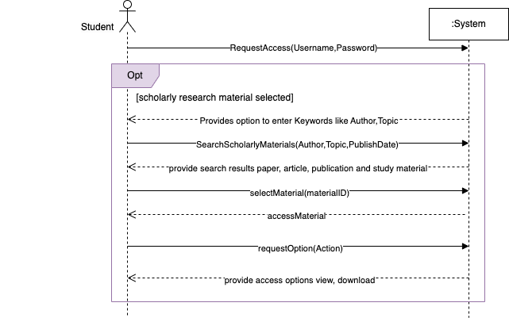

## Generate Enrolment and Retention reports use case description

|  |  |  |
| --- | --- | --- |
| **Use case name:** | Generate Enrolment and Retention Reports | |
| **Scenario:** | Generate enrolment and retention reports for selected courses and programs. | |
| **Triggering event:** | Students initiate a request for access to Enrolment and Retention Reports | |
| Brief description: | The student receives detailed reports containing enrolment information for selected courses and programs. | |
| **Actors:** | Student | |
| **Related use cases** | None | |
| **Stakeholders:** | Students, Administrators, Oakland Hub App Team, Sponsors | |
| **Preconditions:** | Students must authenticate themselves using valid credentials (such as username/password) to gain access to the system.  Access permissions should be correctly configured.  Enrolment data for the selected courses and programs must be available. | |
| **Postconditions:** | Student successfully access the requested enrolment and retention report.  The system records relevant usage statistics, including a selected paper is being accessed or downloaded.  The system makes an entry to tracking table which report has been tracked. | |
| **Flow of activities:** | **Actor** | **System** |
| 1. Student selects reports section.  2. Student selects specific course for which they want to generate reports.  3. Student specifies the time period for the enrolment and retention report.  4. Student access the Enrolment and Retention Report through available actions such as viewing, downloading. | 1.1 System generate a list of available courses and programs.  2.1 System will give a pop-up for the desired time period selection.  3.1 The system will generate Enrolment and Retention Report.  4.1 The system grant’s view or downloading capability of the requested report. |
| **Exception conditions:** | 4.1 If the selected time period is invalid or outside the available data range, The system prompts the student to enter a valid time period within the available data range. | |

## Generate Enrolment and Retention reports System Sequence Diagram

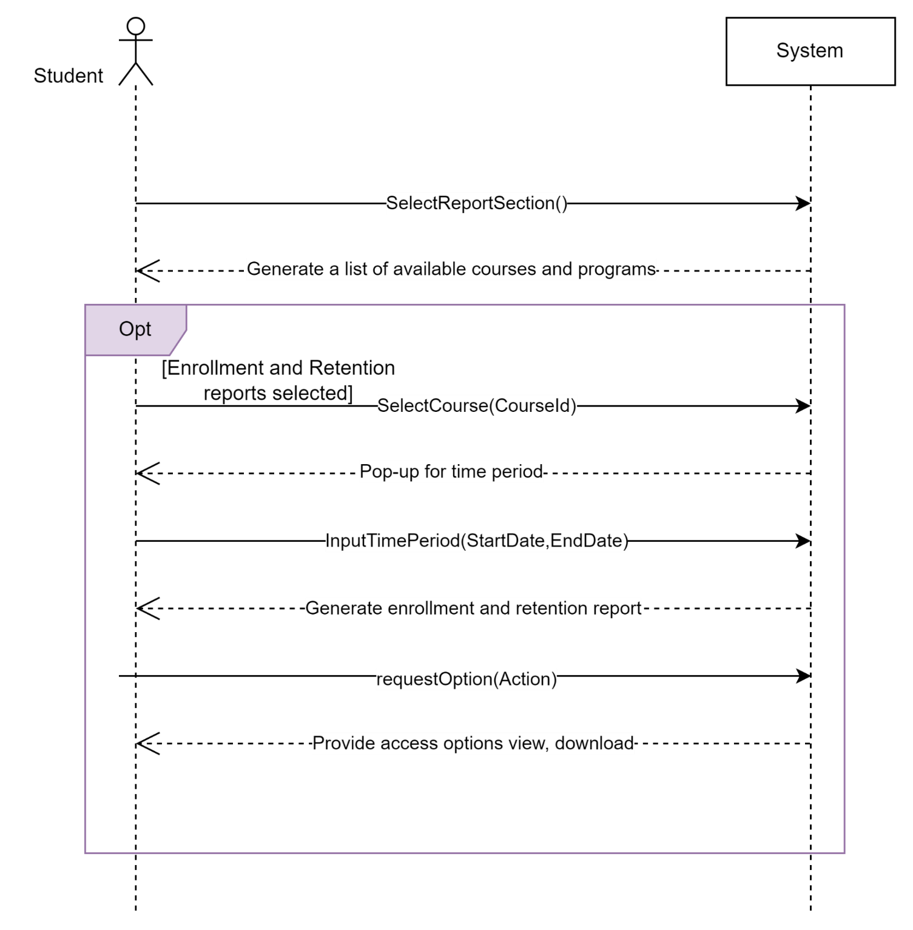

## Access Alumni Success stories use case description

|  |  |  |
| --- | --- | --- |
| **Use Case Name:** | Access Alumni Success Stories | |
| **Scenario:** | Access alumni success stories as per student request | |
| **Triggering Event:** | A student requests access to alumni success stories for informational or inspirational purposes. | |
| **Brief Description:** | The system retrieves and presents alumni success stories based on student requests, allowing them to browse, select, read the stories. | |
| **Actors:** | Student | |
| **Stakeholders:** | Students, Alumni Students, Administrators, Oakland Hub App Team, Sponsors | |
| **Preconditions:** | Alumni success stories must be documented and available in a database or repository. The student must have appropriate permissions to access the stories.  Also please include: User must have an existing account | |
| **Postconditions:** | Students successfully access alumni success stories for personal or academic use.  The system logs the access of each success story for tracking purposes.  The system Facilitates updates or revisions to success stories as requested by students.  Track and save student access and interactions with the stories. | |
| **Flow of Activities:** | **Actor** | **System** |
| 1. Request access to alumni success stories.  2. Specify the purpose of the request (e.g., research, inspiration).  3. Browse and Select story of interest. | 1.1 Gives a pop-up with Options to choose Purpose.  2.1 Grant access to relevant success stories based on the request's purpose.  3.1 provides the pop up with complete details of that success story. |
| **Exception Conditions:** | * 1. If the users enter incorrect credentials, then the system denies access and alerts users to re-enter their credentials or do password reset process. | |

## Access Alumni Success stories System Sequence Diagram

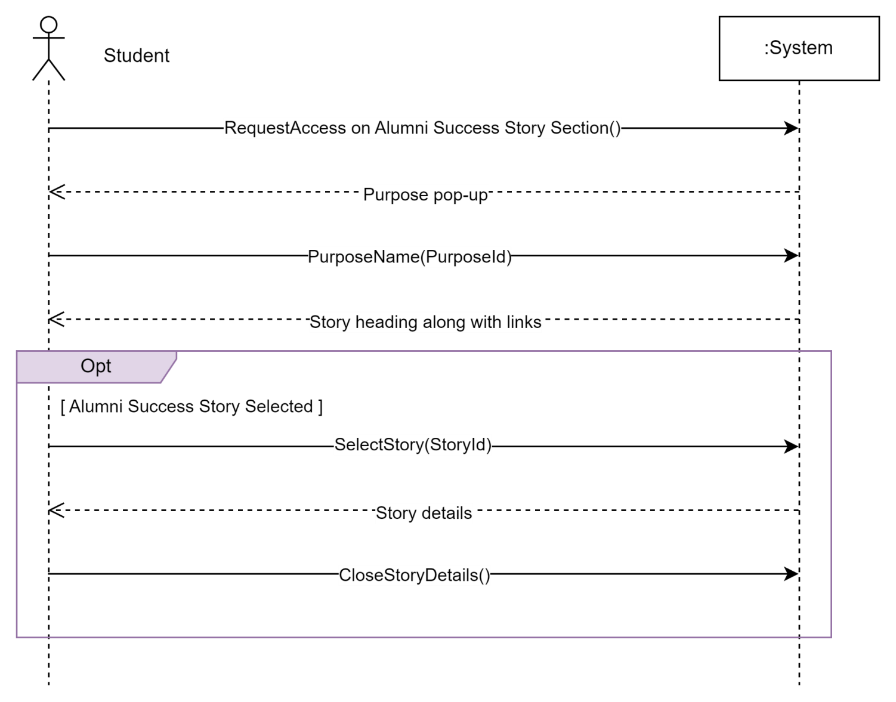

## View Classroom environment use case description

|  |  |  |
| --- | --- | --- |
| **Use case name:** | View Classroom Environment | |
| **Scenario:** | Views Classroom environment as per student request. | |
| **Triggering event:** | Students initiate a request for access to view the Classroom Environment. | |
| **Brief description:** | The system retrieves and presents Classroom Environment based on student requests, allowing them to understand the learning environment. | |
| **Actors:** | Students | |
| **Stakeholders:** | Students, Administrators, Oakland Hub App Team, Sponsors | |
| **Preconditions:** | Students must authenticate themselves using valid credentials (such as username/password) to gain access to the system. Access permissions should be correctly configured. The information on Classroom Environment must be available in a database or repository. | |
| **Postconditions:** | Students successfully access the Classroom Environment to capture previous student’s opinions on professors.  The system logs the access to the classroom environment of every professor for the tracking purposes. | |
| **Flow of activities:** | **Actor** | **System** |
| 1. Log in to the system using credentials.  2. Request access to Classroom environment.  3. Browse and Select Class of interest.  4. Read and analyse the environment of the selected classroom and clicks on close. | 1.1 The system verifies the student’s credentials to authenticate their identity.  2.1 The system requests and presents a pop-up with Options to choose Purpose.  3.1 provide the pop up with  complete details of that Classroom and professor.  4.1 Provides a feedback pop-up. |
| **Exception conditions:** | * 1. If the users enter incorrect credentials, then the system denies access and alerts users to re-enter their credentials or do password reset process. | |

## View Classroom environment System Sequence Diagram

### draw.io file



# Task 6: User Interfaces

## Login Interface

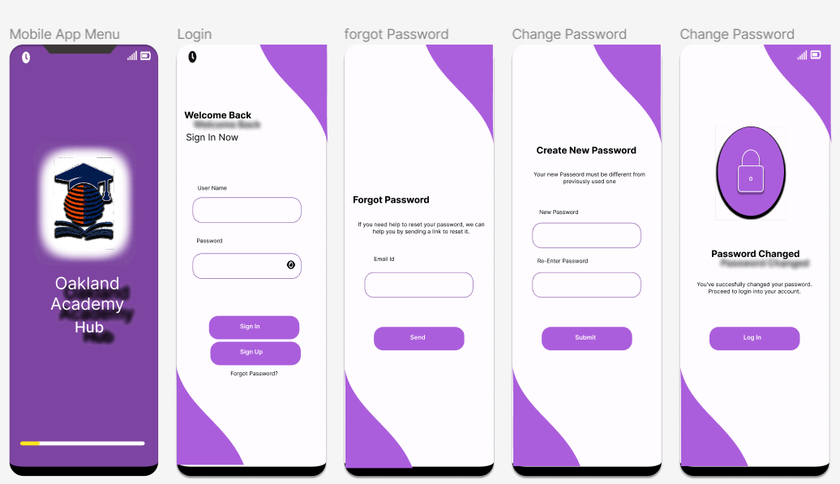

## Subsystem: Career Scope

### Job Roles and Titles User Interface

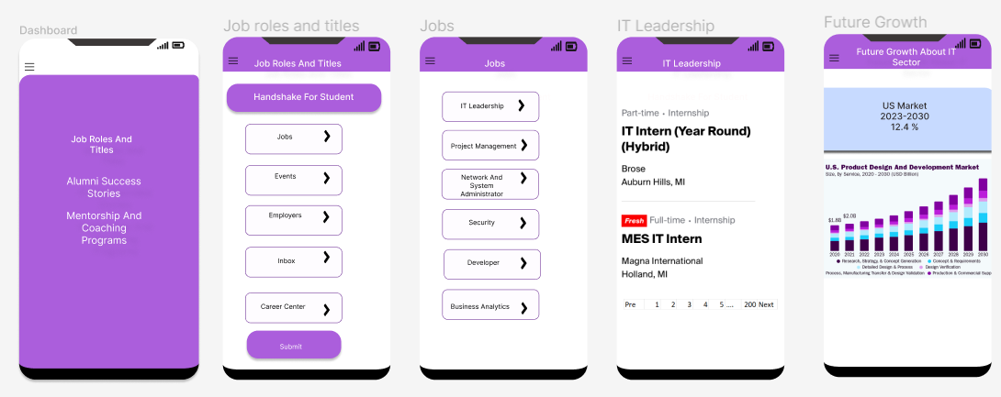

### Alumni Success Story User Interface

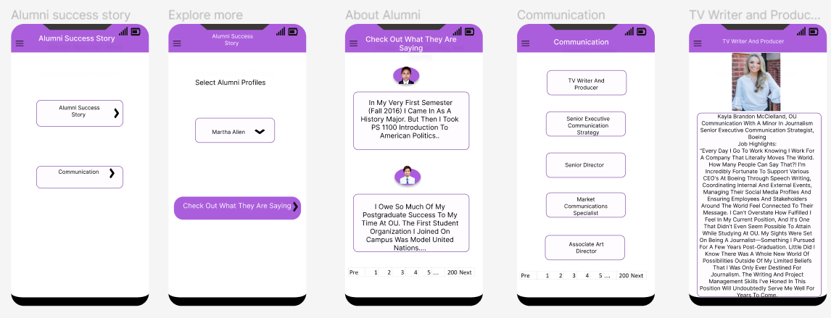

### Mentorship and Coaching Programs User Interface

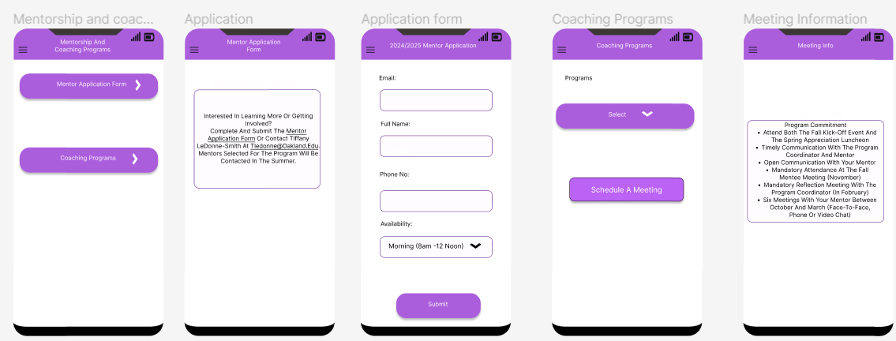

## Subsystem: Subject Library

### Course Document User Interface

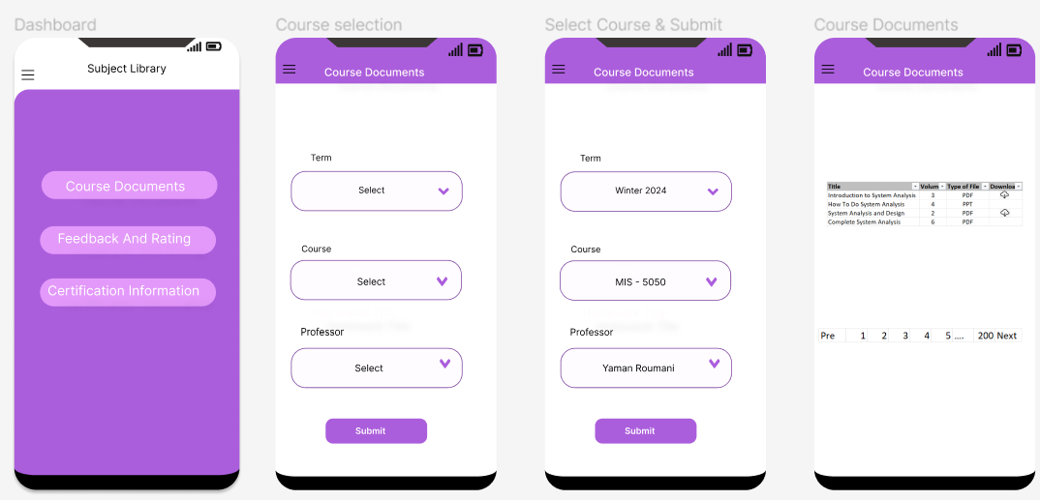

### Feedback and Rating User Interface

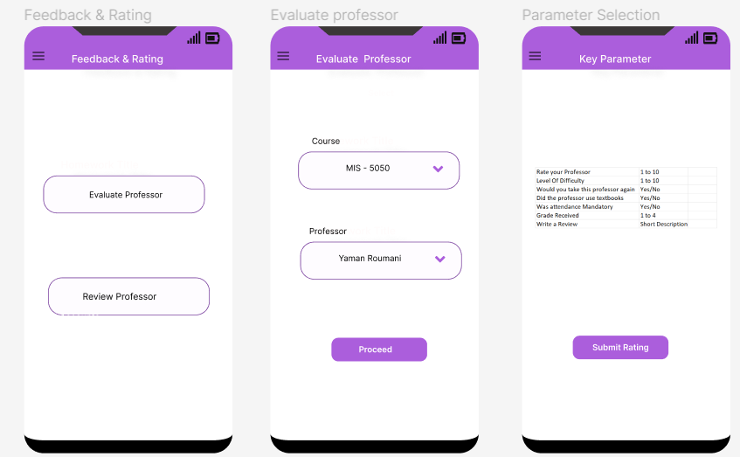

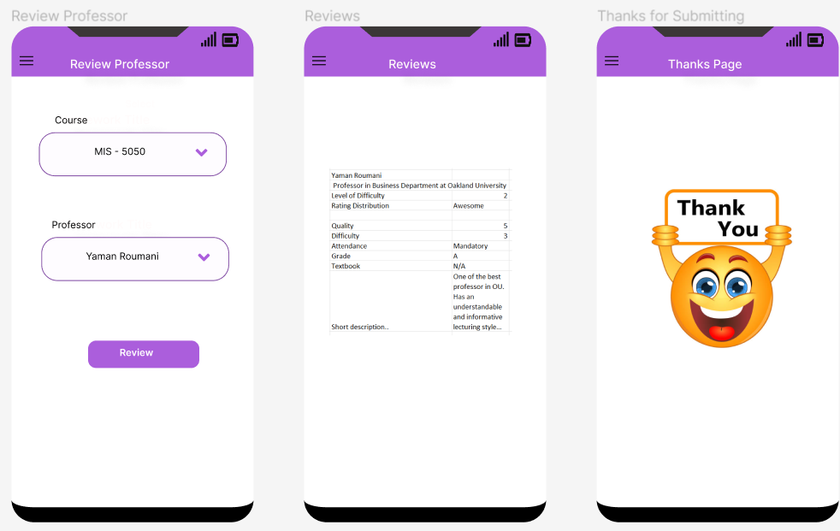

### Certification Information User Interface

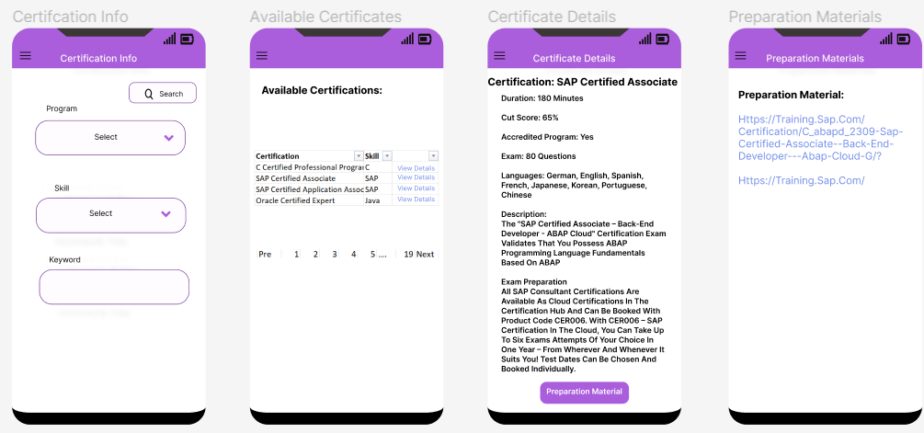

## Subsystem: Staff Review

### Grading policy information User Interface

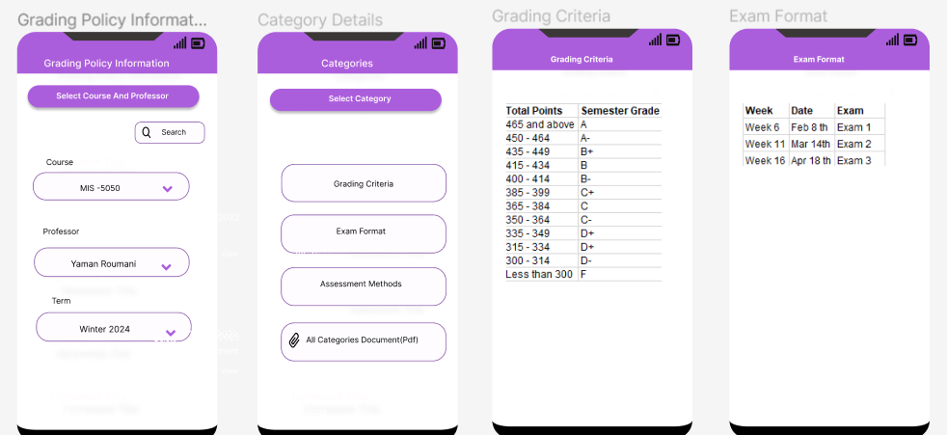

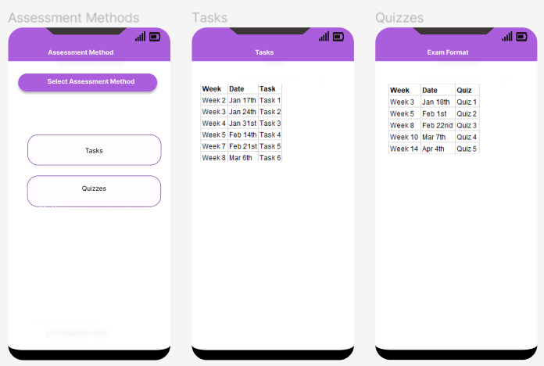

### Information on research productivity and Impact User Interface

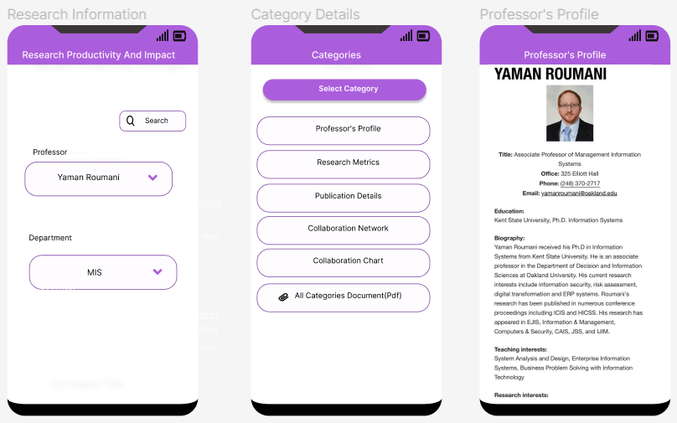

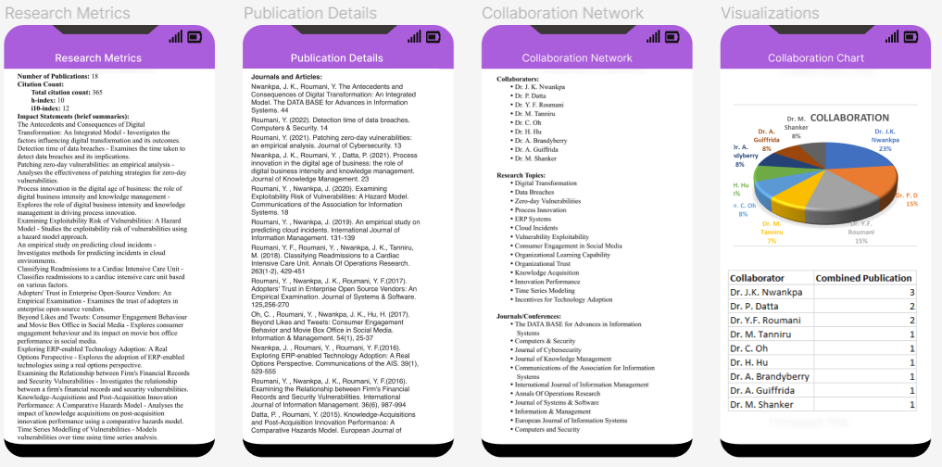

### Information on classroom environment User Interface

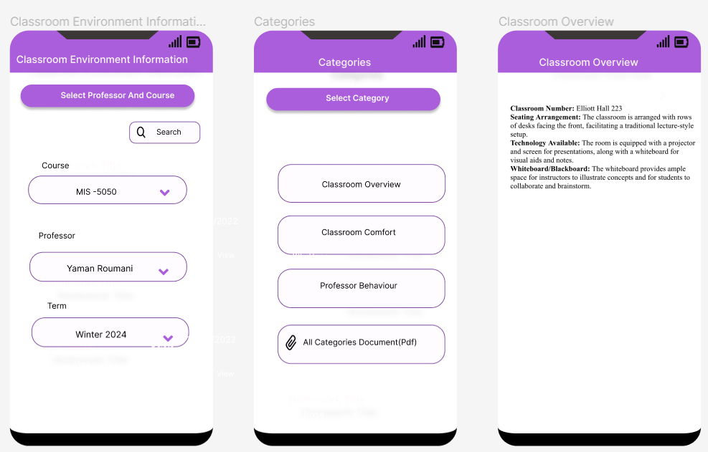

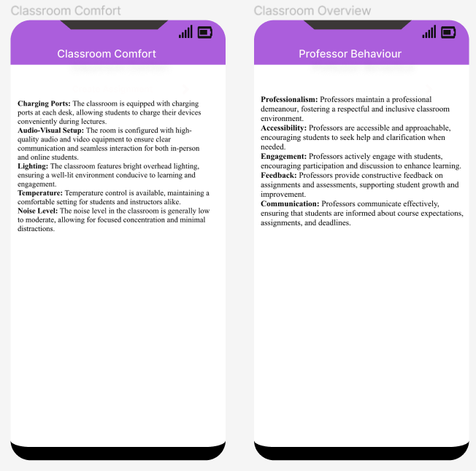

## Subsystem: Reports

### Detailed course reports User Interface

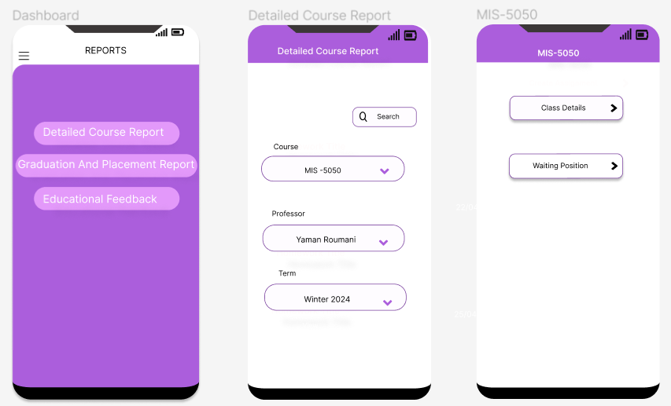

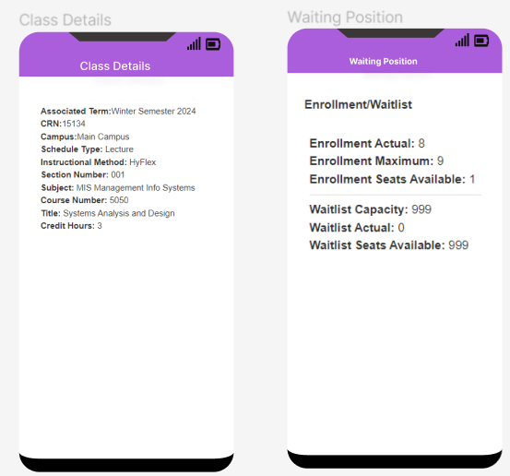

### Graduation and placement reports User Interface

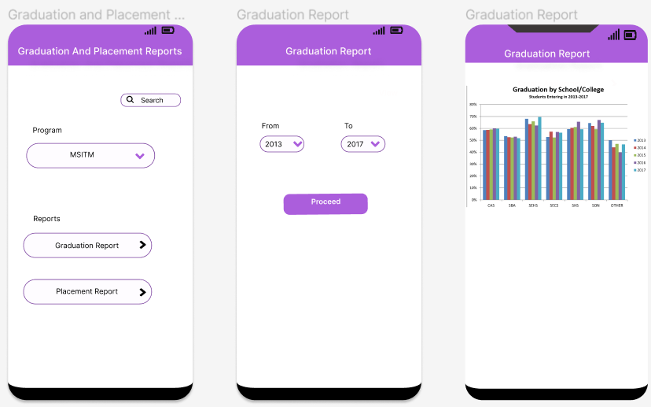

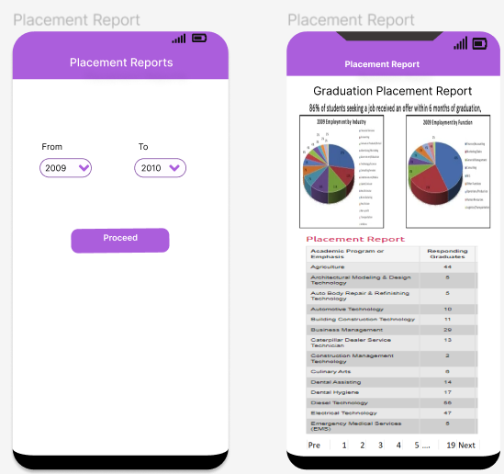

### Educational feedback user Interface

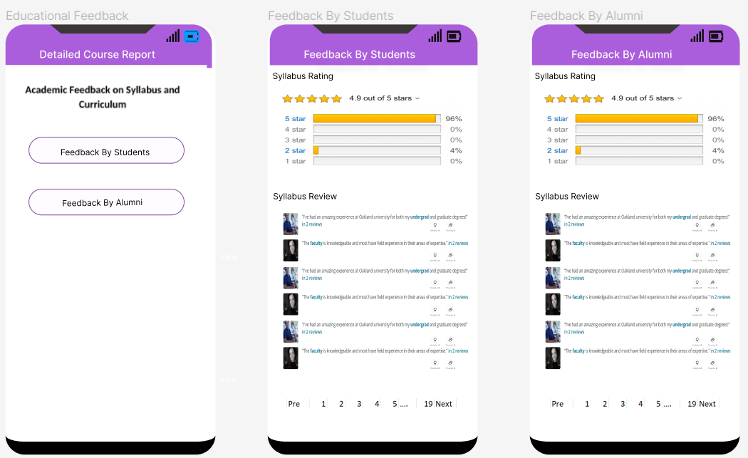

## Link for Figma

<https://www.figma.com/file/VEXn3xe9f01WwLqJdsO2pG/School-Staff-Application-Ui-(Community)?type=design&node-id=0-1&mode=design&t=yQS7lNzFtYvg03Zf-0>

# Task 7: Design Class Diagram (DCD)

